**JavaScript Executor:**

* + JavaScriptExecutor is an Interface
  + It will allow us to execute JavaScript methods through Selenium webdriver
  + In some place’s selenium can't be work at that time we use JavaScript to interact that Web element.

**Syntax:**

JavascriptExecutor js = (JavascriptExecutor) driver;

js.executeScript(Script,Arguments);

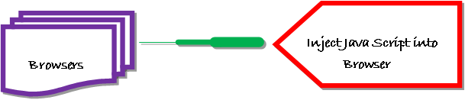

* Script – This is the JavaScript that needs to execute.
* Arguments – It is the arguments to the script. It's optional.

eg :

1. js.executeScript("arguments[0].scrollIntoView();", WebElementName)
2. js.executeScript("window.scrollBy(0,range);")
3. js.executeScript("window.scrollBy(0, 1000);")---> Scroll down
4. js.executeScript("window.scrollBy(0, -3000);") ----> Scroll up
5. js.executeScript("arguments[0].click();", webelementname ) ---> click
6. js.executeScript("document.getElementById('some id').value='someValue';"); 🡪 Value pass
7. Js.executeScript("alert('hello world');"); -🡪 Alert msg
8. js.executeScript("history.go(0)"); 🡪 Refresh
9. string sText = js.executeScript("return document.title;").toString(); 🡪 Get Title
10. js.executeScript("return document.URL;") 🡪get url
11. js.executeScript("window.location = 'https://yahoo.com'"); 🡪 Navigator
12. String string = js.executeScript("return document.documentElement.innerText;").toString(); -> get entire website texts
13. js.executeScript("return arguments[0].innerHTML", Webelement).toString(); 🡪 getText()